Pharmacy Inventory & Prescription Management System

1. Project Name
DuPharma

2. Problem Statement
Many local pharmacies still depend on manual or semi‑manual methods to manage inventory and prescriptions. This results in:
- Frequent stockouts and overstocking due to poor tracking.
- Medicines expiring unnoticed, leading to financial losses.
- Difficulty maintaining accurate prescription history for customers.
- Human errors in sales records and reporting.
- Lack of centralized visibility for admins and managers across branches.
- Time‑consuming report generation and poor decision-making tools.
These inefficiencies reduce productivity, lower service quality, and create compliance risks.

3. Objective
To develop a centralized, user‑role‑based pharmacy management system that:
- Tracks real‑time medicine stock levels and expiry dates.
- Allows pharmacists to record sales and manage customer prescriptions.
- Enables managers to supervise stock, handle returns, and generate reports.
- Provides admins with full system control, user management, and report dashboards.
- Ensures security, accuracy, and automation of daily pharmacy operations.
- Generates analytics such as most sold medicines, daily reports, and alerts.

4. Functional and Non‑Functional Requirements
4.1 Functional Requirements
Admin:
- Manage system users (create, update, deactivate)
- Full CRUD operations on medicines
- Generate and export reports (PDF/Excel)
- Perform CRUD operations on all reports
- Switch between pharmacy branches (Not in our MVP)
Manager:
- Add and update medicines
- Approve product returns
- Generate reports
- Monitor expiry dates and low‑stock medicines
- Oversee pharmacist activities (Not in our MVP)
Pharmacist:
- Record sales transactions
- View customer prescription history
- View low‑stock and expiry alerts
- Create daily activity reports
System Features:
- Dashboard: Most sold medicines, Low stock alerts, Near‑expiry medicines
- Role‑based authentication and authorization
- Inventory tracking by medicine and batch
- Optional multi‑branch support
4.2 Non‑Functional Requirements
- Security: Role‑based access, password hashing, secure authentication
- Performance: Handle 100+ simultaneous operations with fast queries
- Reliability: Consistent data integrity using transactions
- Usability: Simple, intuitive interfaces for pharmacists and managers
- Maintainability: Clean architecture with separation of concerns
- Availability: 99% uptime planned for production environment
- Scalability: Support multiple branches (Not in our MVP)

5. Use‑Case Diagram (Description)
Actors: Admin, Manager, Pharmacist.
Pharmacist: Record sales, Create daily report, View low‑stock alerts, View customer prescription history.
Manager: Add/Update medicines, Approve returns, Generate report, Monitor expiry & low‑stock medicines, Oversee pharmacists (Not in our MVP)
Admin: Manage users, CRUD reports, Generate/export reports, Full CRUD on medicines, Switch branches (optional)
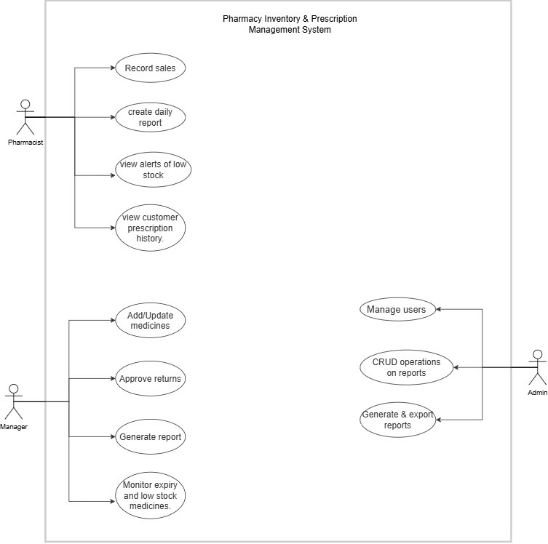

6. Database Diagram (Tables Description)
Essential Tables:
- User (UserId, FullName, Username, PasswordHash, Role, BranchId)
- Medicine (MedicineId, Name, Category, Strength, Unit, ReorderLevel)
- Sales (SaleId, UserId, MedicineId, Quantity, TotalAmount, Date)
- Customer (CustomerId, FullName, Phone, Address)
- Supplier (SupplierId, Name, Contact, Email)

Optional Tables (After the MVP):
- Branches (BranchId, BranchName, Location)
- Audit (AuditId, UserId, Action, Timestamp, Description)
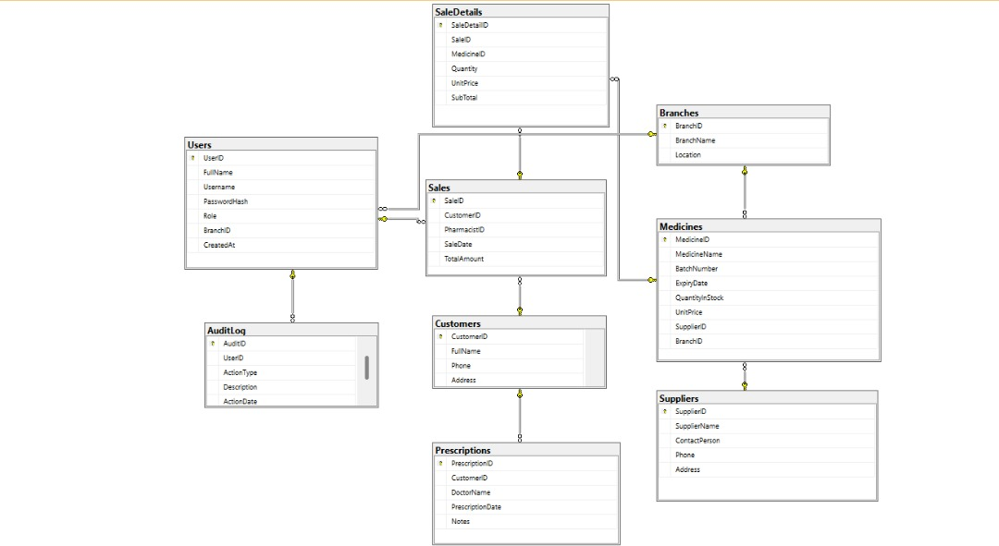

7. Project Timeline
Day 1 : Database setup → SQL tables, relationships, sample data
Day 1- 2 : User roles & authentication → Login system, role‑based access
Day 2 - 4 : Inventory module → Medicine CRUD, suppliers, returns
Day 4 – 6: Sales & reporting → Sales recording, daily reports, export feature
Day 6 - 8 : Dashboard & alerts → Most sold medicines, low stock alerts
Day 9 - 10 : Testing & Deployment → Final testing, documentation, hosting
Day 11- Marking Day: Refining the UI → Solving any issue → Adding more features like branches and Auditing.

Group Members:
- Sheja N M Yves 26500
- Ganza Ibambasi Davy
- Ngoga Mizero Joconde Console
- Nzikwinkunda Aline

